Introduction
- Making plots and static or interactive visualizations is one of the most important tasks in data analysis. It may be a part of the exploratory process; for example, helping identify outliers, needed data transformations, or coming up with ideas for models.
- Matplotlib is the most extensively used library of python for data visualization due to it's high flexibility and extensive functionality that it provides.

Table of Contents
- Setting up
  - Importing matplotlib
  - Matplotlib for Jupyter notebook
  - Dataset
  - Documentation
- Matplotlib basics
  - Make a simple plot
  - Labels, and Legends
  - Size, Colors, Markers, and Line Styles
  - Figures and subplots
- Line Chart
- Bar Chart
- Histogram
- Box plot
- Violin plot
- Scatter plot
- Bubble plot

1. Setting up

Importing matplotlib
Just as we use the np shorthand for NumPy and the pd shorthand for Pandas, we will use standard shorthands for Matplotlib import:
import matplotlib.pyplot as plt
We import the pyplot interface of matplotlib with a shorthand of plt and we will be using it like this in the entire notebook.

Matplotlib for Jupyter notebook
You can directly use matplotlib with this notebook to create different visualizations in the notebook itself. In order to do that, the following command is used:
%matplotlib inline

Documentation
All the functions covered in this notebook and their detail description can be found in the official matplotlib documentation.
# importing required libraries
import numpy as np
import pandas as pd
# importing matplotlib
import matplotlib.pyplot as plt
# display plots in the notebook itself
%matplotlib inline

2. Matplotlib basics

Make a simple plot
Let's create a basic plot to start working with!
height = [150,160,165,185]
weight = [70, 80, 90, 100]
# draw the plot
plt.plot(height, weight)
[<matplotlib.lines.Line2D at 0x286fccdc760>]
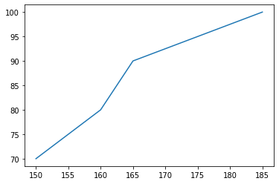
We pass two arrays as our input arguments to plot() method and invoke the required plot. Here note that the first array appears on the x-axis and second array appears on the y-axis of the plot.

Title, Labels, and Legends
- Now that our first plot is ready, let us add the title, and name x-axis and y-axis using methods title(), xlabel() and ylabel() respectively.
# draw the plot
plt.plot(height,weight)
# add title
plt.title("Relationship between height and weight")
# label x axis
plt.xlabel("Height")
# label y axis
plt.ylabel("Weight")
Text(0, 0.5, 'Weight')
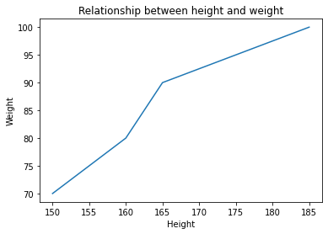
calories_burnt = [65, 75, 95, 99]
# draw the plot for calories burnt
plt.plot(calories_burnt)
# draw the plot for weight
plt.plot(weight)
[<matplotlib.lines.Line2D at 0x286fee7cd00>]
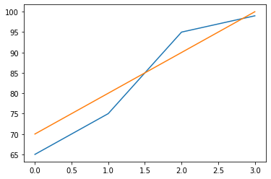
- Adding legends is also simple in matplotlib, you can use the legend() which takes labels and loc as label names and location of legend in the figure as paremeters.
# draw the plot for calories burnt
plt.plot(calories_burnt)
# draw the plot for weight
plt.plot(weight)
# add legend in the lower right part of the figure
plt.legend(labels=['Calories Burnt', 'Weight'], loc='lower right')
<matplotlib.legend.Legend at 0x286fef02be0>
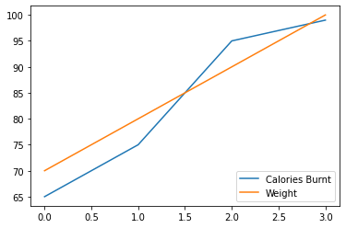
- Notice that in the previous plot, we are not able to understand that each of these values belong to different persons.
- Look at the X axis, can we add labels to show that each belong to different persons?
- The labeled values on any axis is known as a tick.
- You can use the xticks to change both the location of each tick and it's label. Let's see this in an example
# draw the plot
plt.plot(calories_burnt)
plt.plot(weight)
# add legend in the lower right part of the figure
plt.legend(labels=['Calories Burnt', 'Weight'], loc='lower right')
# set labels for each of these persons
plt.xticks(ticks=[0,1,2,3], labels=['p1', 'p2', 'p3', 'p4'])
([<matplotlib.axis.XTick at 0x286fff4a910>,
<matplotlib.axis.XTick at 0x286fff4a8e0>,
<matplotlib.axis.XTick at 0x286fff4a370>,
<matplotlib.axis.XTick at 0x286fff83e50>],
[Text(0, 0, 'p1'), Text(1, 0, 'p2'), Text(2, 0, 'p3'), Text(3, 0, 'p4')])
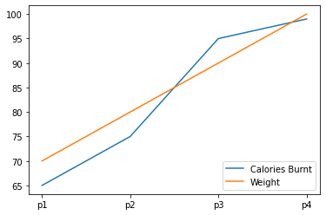

Size, Colors, Markers and Line styles
- You can also specify the size of the figure using method figure() and passing the values as a tuple of the length of rows and columns to the argument figsize.
- The values of length are considered to be in inches.
# figure size in inches
plt.figure(figsize=(15,5))
# draw the plot
plt.plot(calories_burnt)
plt.plot(weight)
# add legend in the lower right part of the figure
plt.legend(labels=['Calories Burnt', 'Weight'], loc='lower right')
# set labels for each of these persons
plt.xticks(ticks=[0,1,2,3], labels=['p1', 'p2', 'p3', 'p4']);
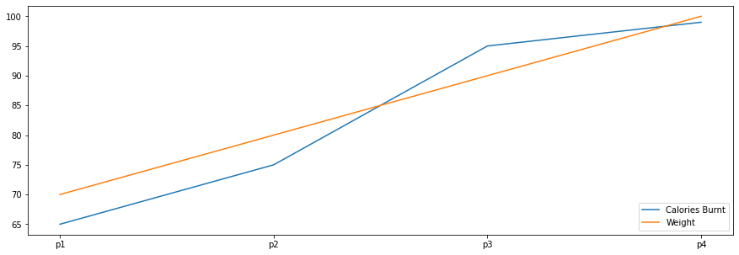
- With every X and Y argument, you can also pass an optional third argument in the form of a string which indicates the colour and line type of the plot.
- The default format is b- which means a solid blue line. In the figure below we use go which means green circles. Likewise, we can make many such combinations to format our plot.
# draw the plot
plt.plot(calories_burnt)
plt.plot(weight, 'y--')
# add legend in the lower right part of the figure
plt.legend(labels=['Calories Burnt', 'Weight'], loc='lower right')
# set labels for each of these persons
plt.xticks(ticks=[0,1,2,3], labels=['p1', 'p2', 'p3', 'p4']);
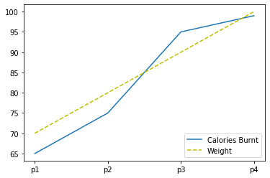
- We can also plot multiple sets of data by passing in multiple sets of arguments of X and Y axis in the plot() method as shown.

Figure and subplots
- We can use subplots() method to add more than one plots in one figure.
- The subplots() method takes two arguments: they are nrows, ncols. They indicate the number of rows, number of columns respectively.
- This method creates two objects: figure and axes which we store in variables fig and ax.
- You plot each figure by specifying its position using row index and column index. Let's have a look at the below example:
# create 2 plots
fig, ax = plt.subplots(nrows=2, ncols=2, figsize=(6,6))
# plot on 0 row and 0 column
ax[0,0].plot(calories_burnt, 'go')
# plot on 0 row and 1 column
ax[0,1].plot(weight)
# set titles for subplots
ax[0,0].set_title("Calories Burnt")
ax[0,1].set_title("Weight")
# set ticks for each of these persons
ax[0,0].set_xticks(ticks=[0,1,2,3]);
ax[0,1].set_xticks(ticks=[0,1,2,3]);
# set labels for each of these persons
ax[0,0].set_xticklabels(labels=['p1', 'p2', 'p3', 'p4']);
ax[0,1].set_xticklabels(labels=['p1', 'p2', 'p3', 'p4']);
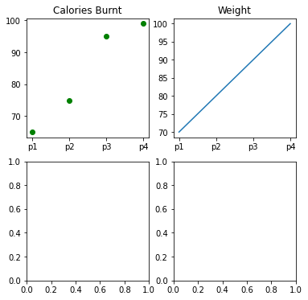
- Notice that in the above figure we have two empty plots, that is because we created 4 subplots ( 2 rows and 2 columns).
- As a data scientist, there will be times when you need to have a common axis for all your subplots. You can do this by using the sharex and sharey paremeters of subplot().
# create 2 plots
fig, ax = plt.subplots(nrows=1, ncols=2, figsize=(6,6), sharex=True, sharey=True)
# plot on 0 row and 0 column
ax[0].plot(calories_burnt,'go')
# plot on 0 row and 1 column
ax[1].plot(weight)
# set titles for subplots
ax[0].set_title("Calories Burnt")
ax[1].set_title("Weight")
# set ticks for each of these persons
ax[0].set_xticks(ticks=[0,1,2,3]);
ax[1].set_xticks(ticks=[0,1,2,3]);
# set labels for each of these persons
ax[0].set_xticklabels(labels=['p1', 'p2', 'p3', 'p4']);
ax[1].set_xticklabels(labels=['p1', 'p2', 'p3', 'p4']);
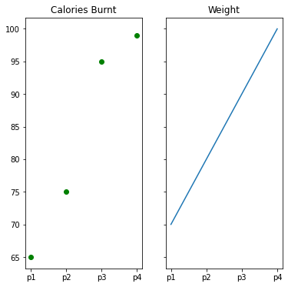
x=np.array([1, 2, 3, 4, 5])
# making subplots
fig, ax = plt.subplots(2, 2)
# set data with subplots and plot
ax[0, 0].plot(x, x)
ax[0, 1].plot(x, x*2)
ax[1, 0].plot(x, x*x)
ax[1, 1].plot(x, x*x*x)
plt.show()
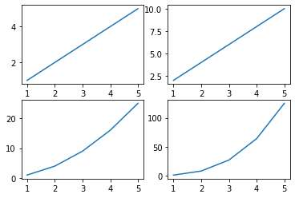
- Notice in the above plot, now both x and y axes are only labelled once for each of the outer plots. This is because the inner plots "share" both the axes.
- Also, there are only two plots since we decreased the number of rows to 1 and columns to 2 in the subplot().
- You can learn more about subplots here.
import matplotlib.pyplot as plt
import matplotlib.image as img
# reading the image
testImage = img.imread('kittu.jpg')
# displaying the image
plt.imshow(testImage)
<matplotlib.image.AxesImage at 0x286802d5970>
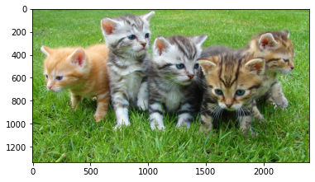
# displaying the image as an array
print(testImage)
[[[ 76 115 48]
[ 73 112 45]
[ 81 120 53]
...
[106 143 73]
[ 98 138 67]
[ 95 135 62]]
[[ 79 118 53]
[ 79 118 53]
[ 84 123 58]
...
[105 141 71]
[100 140 67]
[109 149 76]]
[[ 79 119 57]
[ 82 120 59]
[ 85 121 59]
...
[116 149 78]
[105 146 70]
[115 157 81]]
...
[[ 91 156 52]
[ 90 156 46]
[ 95 159 45]
...
[ 47 60 0]
[ 44 55 0]
[ 49 59 0]]
[[ 93 156 52]
[ 93 156 49]
[ 97 161 47]
...
[ 64 82 8]
[ 59 74 7]
[ 66 80 18]]
[[ 97 158 55]
[ 96 158 51]
[ 97 160 46]
...
[ 60 84 8]
[ 52 74 2]
[ 66 87 20]]]
# displaying the shape of the image
print(testImage.shape)
# modifying the shape of the image
modifiedImage = testImage[:, :, 0]
# displaying the modified image
plt.imshow(modifiedImage)
(1334, 2400, 3)
<matplotlib.image.AxesImage at 0x28680ca3a90>
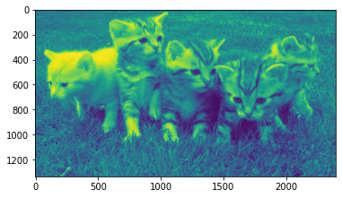
print(testImage.shape)
# modifying the shape of the image
modifiedImage = testImage[500:2000, 1000:2000, 1]
# displaying the modified image
plt.imshow(modifiedImage)
(1334, 2400, 3)
<matplotlib.image.AxesImage at 0x286fee90f40>
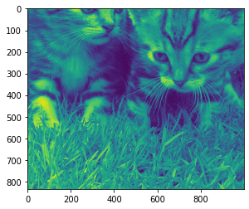
x = [1, 2, 3, 4]
# this will explode the 1st wedge
# i.e. will separate the 1st wedge
# from the chart
e =(0.1, 0, 0, 0)
# This will plot a simple pie chart
plt.pie(x, explode = e)
# Title to the plot
plt.title("Pie chart")
plt.show()
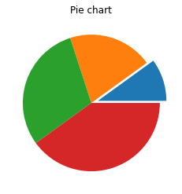

Working on 3D picture
fig = plt.figure()
axis = plt.axes(projection='3d')
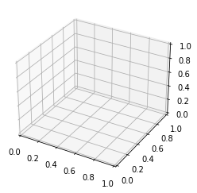
# syntax for 3-D projection
ax = plt.axes(projection ='3d')
# defining all 3 axis
z = np.linspace(0, 1, 100)
x = z * np.sin(25 * z)
y = z * np.cos(25 * z)
# plotting
ax.plot3D(x, y, z, 'blue')
ax.set_title('3D line plot')
plt.show()
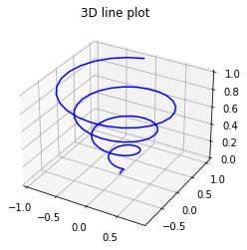
# syntax for 3-D projection
ax = plt.axes(projection ='3d')
# defining axes
z = np.linspace(0, 1, 100)
x = z * np.sin(25 * z)
y = z * np.cos(25 * z)
c = x + y
ax.scatter(x, y, z, c = c)
# syntax for plotting
ax.set_title('3d Scatter plot')
plt.show()
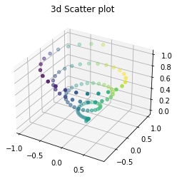
# defining surface and axes
x = np.outer(np.linspace(-2, 2, 10), np.ones(10))
y = x.copy().T
z = np.cos(x ** 2 + y ** 3)
fig = plt.figure()
# syntax for 3-D plotting
ax = plt.axes(projection='3d')
# syntax for plotting
ax.plot_surface(x, y, z, cmap='Spectral',\
edgecolor='blue')
ax.set_title('Surface plot')
plt.show()
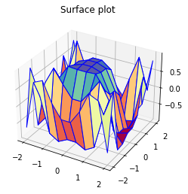
def function(x, y):
return np.sin(np.sqrt(x ** 2 + y ** 2))
x = np.linspace(-10, 10, 40)
y = np.linspace(-10, 10, 40)
X, Y = np.meshgrid(x, y)
Z = function(X, Y)
fig = plt.figure(figsize=(15, 10))
ax = plt.axes(projection='3d')
ax.plot_surface(X, Y, Z, cmap='magma', alpha=0.8)
ax.set_title('3D Contour Plot of function(x, y) =\
sin(sqrt(x^2 + y^2))', fontsize=20)
ax.set_xlabel('x', fontsize=12)
ax.set_ylabel('y', fontsize=12)
ax.set_zlabel('z', fontsize=12)
plt.show()
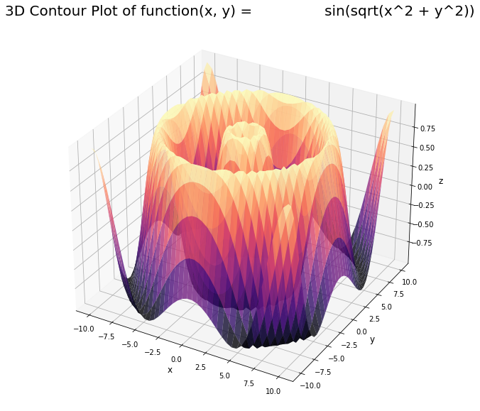

Load dataset
Let's load a dataset and have a look at first 5 rows.
# read the dataset
data_BM = pd.read_csv('bigmart_data.csv')
# drop the null values
data_BM = data_BM.dropna(how="any")
# view the top results
data_BM.head()
Item_Identifier Item_Weight Item_Fat_Content Item_Visibility \
0 FDA15 9.300 Low Fat 0.016047
1 DRC01 5.920 Regular 0.019278
2 FDN15 17.500 Low Fat 0.016760
4 NCD19 8.930 Low Fat 0.000000
5 FDP36 10.395 Regular 0.000000
Item_Type Item_MRP Outlet_Identifier Outlet_Establishment_Year \
0 Dairy 249.8092 OUT049 1999
1 Soft Drinks 48.2692 OUT018 2009
2 Meat 141.6180 OUT049 1999
4 Household 53.8614 OUT013 1987
5 Baking Goods 51.4008 OUT018 2009
Outlet_Size Outlet_Location_Type Outlet_Type Item_Outlet_Sales
0 Medium Tier 1 Supermarket Type1 3735.1380
1 Medium Tier 3 Supermarket Type2 443.4228
2 Medium Tier 1 Supermarket Type1 2097.2700
4 High Tier 3 Supermarket Type1 994.7052
5 Medium Tier 3 Supermarket Type2 556.6088

3. Line Chart
- We will create a line chart to denote the mean price per item. Let's have a look at the code.
- With some datasets, you may want to understand changes in one variable as a function of time, or a similarly continuous variable.
- In matplotlib, line chart is the default plot when using the plot().
price_by_item = data_BM.groupby('Item_Type').Item_MRP.mean()[:10]
price_by_item
Item_Type
Baking Goods 125.795653
Breads 141.300639
Breakfast 134.090683
Canned 138.551179
Dairy 149.481471
Frozen Foods 140.095830
Fruits and Vegetables 145.418257
Hard Drinks 140.102908
Health and Hygiene 131.437324
Household 149.884244
Name: Item_MRP, dtype: float64
# mean price based on item type
price_by_item = data_BM.groupby('Item_Type').Item_MRP.mean()[:10]
x = price_by_item.index.tolist()
y = price_by_item.values.tolist()
# set figure size
plt.figure(figsize=(14, 8))
# set title
plt.title('Mean price for each item type')
# set axis labels
plt.xlabel('Item Type')
plt.ylabel('Mean Price')
# set xticks
plt.xticks(labels=x, ticks=np.arange(len(x)))
plt.plot(x, y)
[<matplotlib.lines.Line2D at 0x28681366550>]
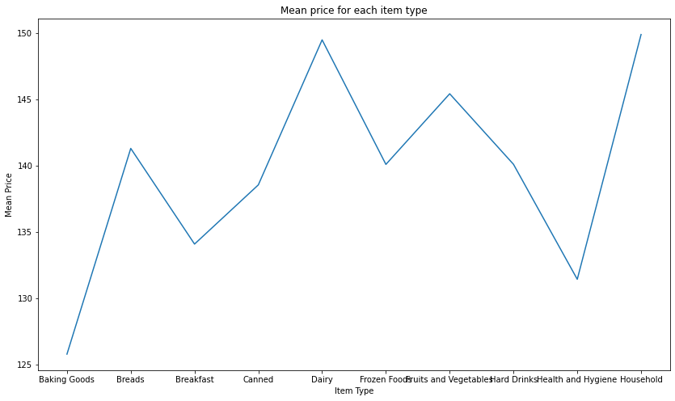

4. Bar Chart
- Suppose we want to have a look at what is the mean sales for each outlet type?
- A bar chart is another simple type of visualization that is used for categorical variables.
- You can use plt.bar() instead of plt.plot() to create a bar chart.
# sales by outlet size
sales_by_outlet_size = data_BM.groupby('Outlet_Size').Item_Outlet_Sales.mean()
# sort by sales
sales_by_outlet_size.sort_values(inplace=True)
x = sales_by_outlet_size.index.tolist()
y = sales_by_outlet_size.values.tolist()
# set axis labels
plt.xlabel('Outlet Size')
plt.ylabel('Sales')
# set title
plt.title('Mean sales for each outlet type')
# set xticks
plt.xticks(labels=x, ticks=np.arange(len(x)))
plt.bar(x, y, color=['red', 'orange', 'magenta'])
<BarContainer object of 3 artists>
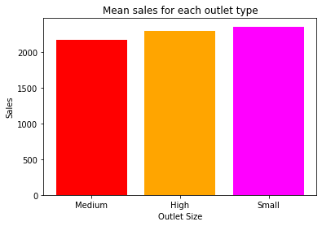

5. Histogram
- Distribution of Item price
- Histograms are a very common type of plots when we are looking at data like height and weight, stock prices, waiting time for a customer, etc which are continuous in nature.
- Histogram’s data is plotted within a range against its frequency.
- Histograms are very commonly occurring graphs in probability and statistics and form the basis for various distributions like the normal -distribution, t-distribution, etc.
- You can use plt.hist() to draw a histogram. It provides many parameters to adjust the plot, you can explore more here.
# title
plt.title('Item MRP (price) distribution')
# xlabel
plt.xlabel('Item_MRP')
# ylabel
plt.ylabel('Frequency')
# plot histogram
plt.hist(data_BM['Item_MRP'], bins=20, color='lightblue');
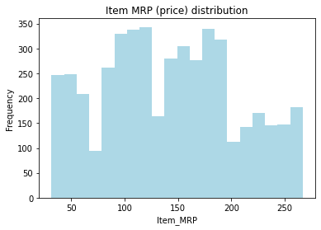

6. Box Plots
- Distribution of sales
- Box plot shows the three quartile values of the distribution along with extreme values.
- The “whiskers” extend to points that lie within 1.5 IQRs of the lower and upper quartile, and then observations that fall outside this range are displayed independently.
- This means that each value in the boxplot corresponds to an actual observation in the data.
- Let's try to visualize the distributio of Item_Outlet_Sales of items.
data = data_BM[['Item_Outlet_Sales']]
# create outlier point shape
red_diamond = dict(markerfacecolor='r', marker='D')
# set title
plt.title('Item Sales distribution')
# make the boxplot
plt.boxplot(data.values, labels=['Item Sales'], flierprops=red_diamond);
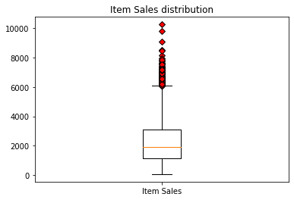
- You can also create multiple boxplots for different columns of your dataset.
- In order to plot multiple boxplots, you can use the same subplots() that we saw earlier.
- Let's see Item_Weight, Item_MRP distribution together
data = data_BM[['Item_Weight', 'Item_MRP']]
# create outlier point shape
red_diamond = dict(markerfacecolor='r', marker='D')
# generate subplots
fig, ax = plt.subplots()
# make the boxplot
plt.boxplot(data.values, labels=['Item Weight', 'Item MRP (price)'], flierprops=red_diamond);
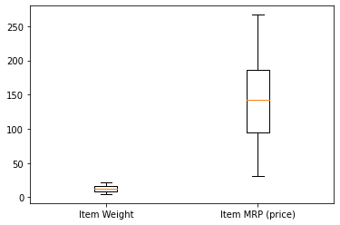

7. Violin Plots
- Density distribution of Item weights and Item price
data = data_BM[['Item_Weight', 'Item_MRP']]
# generate subplots
fig, ax = plt.subplots()
# add labels to x axis
plt.xticks(ticks=[1,2], labels=['Item Weight', 'Item MRP'])
# make the violinplot
plt.violinplot(data.values);
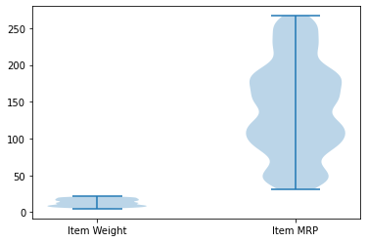

8. Scatter Plots
- Relative distribution of item weight and it's visibility
- It depicts the distribution of two variables using a cloud of points, where each point represents an observation in the dataset.
- This depiction allows the eye to infer a substantial amount of information about whether there is any meaningful relationship between them.
NOTE : Here, we are going to use only a subset of the data for the plots.
# set label of axes
plt.xlabel('Item_Weight')
plt.ylabel('Item_Visibility')
# plot
plt.scatter(data_BM["Item_Weight"][:200], data_BM["Item_Visibility"][:200])
<matplotlib.collections.PathCollection at 0x2868156f6a0>
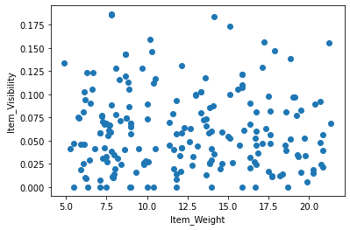

9. Bubble Plots
- Relative distribution of sales, item price and item visibility
- Let's make a scatter plot of Item_Outlet_Sales and Item_MRP and make the size of bubbles by the column Item_Visibility.
- Bubble plots let you understand the interdependent relations among 3 variables.
Note that we are only using a subset of data for the plots.
# set label of axes
plt.xlabel('Item_MRP')
plt.ylabel('Item_Outlet_Sales')
# set title
plt.title('Item Outlet Sales vs Item MRP (price)')
# plot
plt.scatter(data_BM["Item_MRP"][:100], data_BM["Item_Outlet_Sales"][:100], s=data_BM["Item_Visibility"][:100]*1000, c='red')
<matplotlib.collections.PathCollection at 0x28681401df0>
